CHAPTER 9: Sedimentary, igneous and metamorphic rocks
Worksheet 9.6

Tracking changes
in the rock
Science Quest 8: pages 310–13

Answers

Trapped!
1. The photo below shows an insect fossilised in amber.
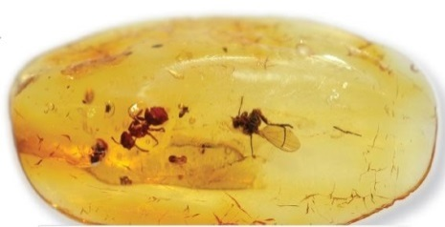  Photo: falk / Shutterstock.com | (a) Explain how this fossil formed.  The insect got stuck in tree sap oozing from a tree. It eventually became encased in the sap. The sap was eventually buried and hardened into a fossil over time.  (b) Explain why there has been very little decay over millions of years.  The lack of air, water and decomposers has ensured the preservation.

Fossils in a logical sequence
2. The evolution of life on Earth can be followed using fossils. In general, life appeared in its simplest form and then over billions of years more complex organisms evolved. Arrange the four drawings of fossils below in a logical evolutionary sequence using the letters A to D.
B, D, C, A
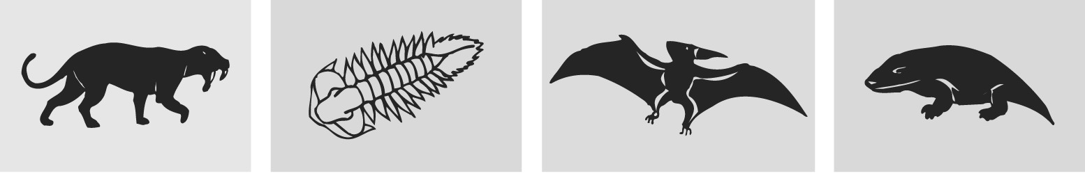
A. Sabre-toothed tiger | B. Trilobite (invertebrate) | C. Pterodactyl | D. Early amphibian

Reading the history
3. The following sequence of rocks was revealed in a road cutting. The events are listed in a random order. Arrange the events (using the letters A to K) in the correct sequence.
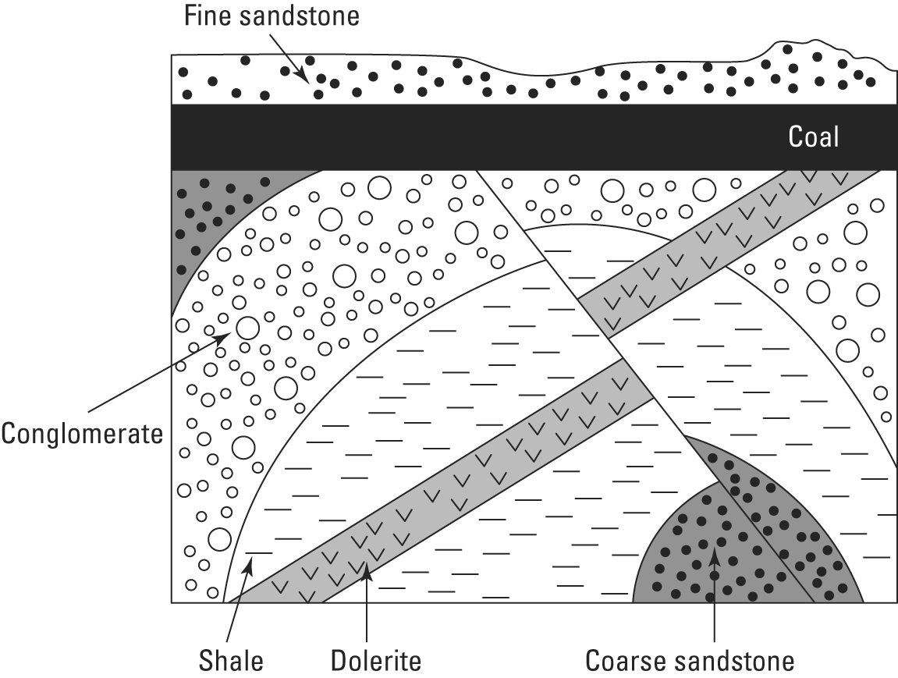 | A. Fine sandstone layer is deposited  B. Shale deposited on top of coarse sandstone  C. Sedimentary layers folded  D. Land sinks and coal layer is deposited  E. Rock layers fault  F. Coarse sandstone deposited on top of conglomerate  G. Land is uplifted and extensive erosion occurs  H. Coarse sandstone deposited  I. Dolerite intrudes through folded layers  J. Uplift and erosion produces the present day landscape  K. Conglomerate deposited  Sequence:  H, B, K, F, C, I, E, G, D, A, J

